**Analyzing Cybercrime Trends and Developing**

**Mitigation Strategies**

**TEAM MEMBERS**

1. YOGESH RHAJA . S
2. SHIEK VASEER . S
3. RUBAN RAJ .N
4. DINESH KUMAR .B
5. ABIMANI .K

**Software Requirements :**

**1. Data Collection and Analysis :**

- Requirement: The software should be able to collect data from various sources such as network logs, security alerts, social media, and dark web forums.

- Requirement: Implement algorithms for data analysis to identify patterns, anomalies, and trends in cybercrime activities.

- Requirement: Support for both real-time and historical data analysis.

2. **Visualization Tools :**

- Requirement: Integration with data visualization libraries or tools to create interactive graphs, charts, and maps for better understanding and presentation of the analyzed data.

- Requirement: Customizable dashboards to display key metrics and insights.

3. **Machine Learning and AI :**

- Requirement: Incorporate machine learning models for predictive analysis and anomaly detection.

- Requirement: Ability to train and retrain models based on new data and feedback.

4. **Security and Compliance :**

- Requirement: Ensure data security and compliance with regulations such as GDPR, HIPAA, etc.

- Requirement: Implement user authentication and authorization mechanisms to control access to sensitive data and features.

5. **Alerting and Notification :**

- Requirement: Capability to generate alerts and notifications for potential cyber threats or breaches based on predefined rules and thresholds.

- Requirement: Support for integration with external notification systems such as email, SMS, or Slack.

6. **Collaboration and Reporting :**

- Requirement: Collaboration features to facilitate teamwork and information sharing among analysts.

- Requirement: Generate detailed reports on cybercrime trends, mitigation strategies, and recommended actions.

7. **Integration and Scalability :**

- Requirement: Ability to integrate with existing security tools and infrastructure.

- Requirement: Scalability to handle large volumes of data and increasing computational demands.

8. **User Interface :**

- Requirement: Intuitive and user-friendly interface for easy navigation and interaction.

- Requirement: Support for customization of views and preferences based on user roles and preferences.

9. **Documentation and Support :**

- Requirement: Comprehensive documentation including installation guides, user manuals, and API references.

- Requirement: Ongoing technical support and maintenance to address issues and updates.

10. **Performance and Reliability :**

- Requirement: Ensure high performance and reliability under heavy loads and continuous operation.

- Requirement: Implement logging and monitoring functionalities to track system health and performance metrics.

**Project description :**

In today's digital age, cybercrime poses a significant threat to individuals, organizations, and nations alike. The rapid evolution of technology has enabled cybercriminals to devise sophisticated techniques to exploit vulnerabilities in digital systems. As such, it's imperative to undertake a comprehensive project aimed at analyzing cybercrime trends and formulating effective mitigation strategies to safeguard against these threats.

**Cybercrime Trend Analysis :** Conduct in-depth research to identify prevalent cybercrime trends, including types of attacks, targeted sectors, and emerging threats. Utilize various sources such as cybersecurity reports, case studies, and threat intelligence feeds to gather relevant data.

**Data Collection and Analysis :** Gather data related to cybercrime incidents, including attack vectors, frequency, and impact. Employ statistical analysis and data visualization techniques to identify patterns, correlations, and outliers in the data.

**Identification of Vulnerabilities :** Assess the common vulnerabilities exploited by cybercriminals, such as software vulnerabilities, social engineering tactics, and human error. Analyze root causes and contributing factors to better understand the cybersecurity landscape.

**Risk Assessment** : Evaluate the potential risks associated with different cybercrime threats based on their likelihood and impact. Prioritize risks according to their severity and develop risk mitigation strategies accordingly.

**Development of Mitigation Strategies :** Based on the findings from the analysis, devise proactive measures and mitigation strategies to enhance cybersecurity resilience. This may include implementing technical controls, improving security awareness training, and enhancing incident response capabilities.

**Policy Recommendations** : Formulate policy recommendations for stakeholders at organizational and governmental levels to address systemic issues and regulatory gaps in cybersecurity.

**Collaboration and Knowledge Sharing :** Foster collaboration with industry partners, government agencies, and academic institutions to share insights, best practices, and threat intelligence. Engage in community outreach and awareness campaigns to promote cybersecurity awareness and education.

**Continuous Monitoring and Adaptation :** Establish mechanisms for continuous monitoring of cyber threats and update mitigation strategies accordingly. Stay abreast of emerging technologies and evolving threat landscapes to ensure proactive defense against cyber threats.

.**Risk Mitigation by using ZenGRC :**

Understanding how to apply risk mitigation best practices is crucial as organizations navigate challenges, from cybersecurity threats to regulatory compliance. Let’s explore how leveraging a tool like ZenGRC can transform your risk mitigation process, making it more efficient, comprehensive, and aligned with your business objectives.

**Identifying and Assessing Risks :**

The first step in any effective risk mitigation strategy is understanding your organization’s risks thoroughly. ZenGRC simplifies risk identification by providing a centralized platform for monitoring risks across various departments and projects. This ensures that your organization focuses on the most significant risks, making your mitigation efforts more targeted and effective.

**Creating a Risk Mitigation Plan :**

Once risks are identified and assessed, the next step is to develop a strategic plan to address them. ZenGRC offers template-based planning tools that guide you through creating comprehensive risk mitigation plans. These templates streamline the planning process and ensure that all critical risk mitigation elements are considered, including risk acceptance, avoidance, transfer, and reduction strategies

**Action Plans and Mitigation Efforts :**

With ZenGRC, implementing your risk mitigation strategies becomes seamless. The platform allows you to assign tasks and responsibilities, set deadlines, and track progress in real-time. Whether enhancing cybersecurity measures, updating compliance policies, or conducting regular risk assessments, ZenGRC ensures that your mitigation efforts are executed efficiently and effectively.

**Continuous Monitoring and Reporting :**

An essential aspect of risk mitigation is the ongoing monitoring of risk levels and the effectiveness of your mitigation strategies. ZenGRC’s dashboard provides a real-time overview of your organization’s risk posture, enabling business leaders to make informed decisions based on current data.

**Education and Engagement :**

Beyond the technical aspects of risk mitigation, fostering a risk-aware culture within your organization is vital. ZenGRC supports this by providing resources for employeetraining andawareness programs. Educating your team about the importance of risk management and their role in the process can enhance your organization’s overall risk resilience.

**Analysis the Data loss :**

import pandas as pd

import matplotlib.pyplot as plt

# Read the CSV file into a pandas DataFrame

df = pd.read_csv('nan.csv')

# Group the data by 'Region' and calculate the total data lost for each region

grouped_data = df.groupby('Region')['Average Data Lost (in USD)'].sum()

# Create the histogram

plt.figure(figsize=(10, 6))

grouped_data.plot(kind='bar', color='skyblue')

plt.title('Total Data Lost by Cybercrime Incidents in Different Regions')

plt.xlabel('Region')

plt.ylabel('Total Data Lost (in USD)')

plt.xticks(rotation=45)

plt.grid(axis='y', linestyle='--', alpha=0.7)

plt.tight_layout()

# Show the histogram

plt.show()

**Screenshot of dataloss :**

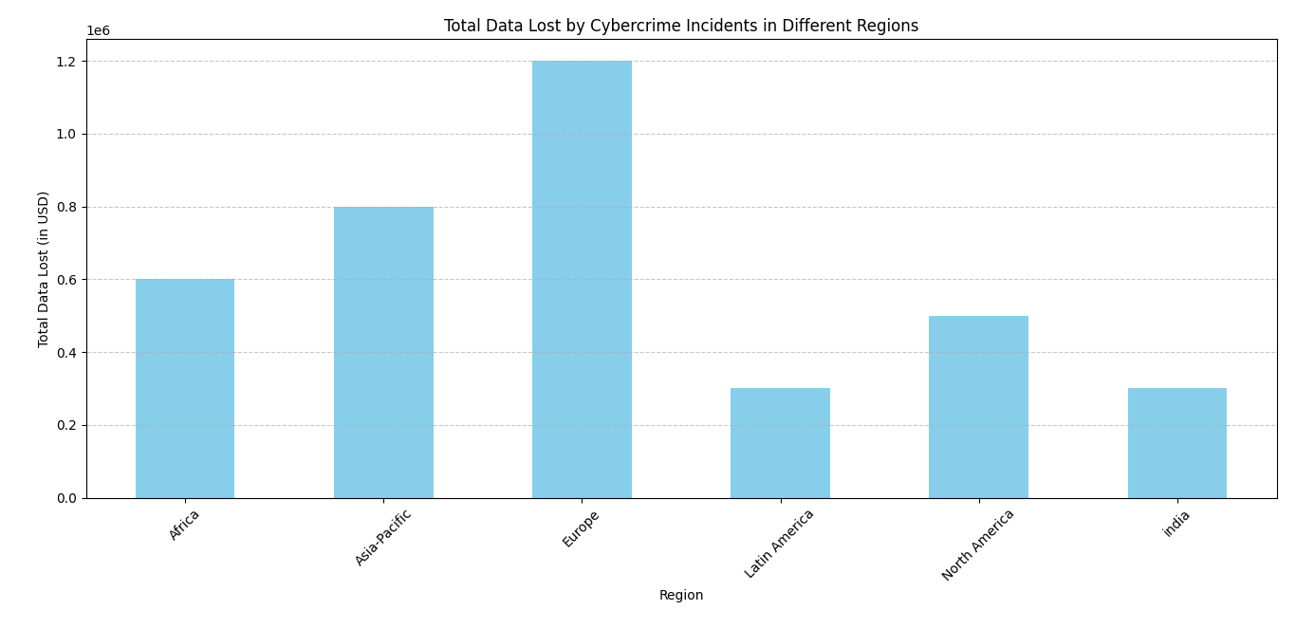

**Developing mitigation strategies :**

1. **Risk Assessment :** Understand your organization's assets, vulnerabilities, and potential threats. Conduct a comprehensive risk assessment to identify potential risks and prioritize them based on their likelihood and impact.

2.**Threat Intelligence** : Stay informed about the latest cyber threats and vulnerabilities relevant to your organization. Subscribe to threat intelligence feeds and engage with cybersecurity communities to stay updated.

3. **Defense in Depth :** Implement multiple layers of defense to protect your organization's assets. This includes network security, endpoint security, access controls, encryption, and monitoring systems.

4. **Patch Management :** Establish a robust patch management process to ensure that software, operating systems, and firmware are regularly updated with the latest security patches. Vulnerabilities in outdated software are often exploited by attackers.

5. **Access Control and Authentication :** Enforce strong access controls and authentication mechanisms to restrict access to sensitive data and systems. Implement multi-factor authentication (MFA) where possible to enhance security.

6. **Data Protection :** Encrypt sensitive data both in transit and at rest. Implement data loss prevention (DLP) solutions to monitor and prevent unauthorized access or exfiltration of data.

7. **Employee Training and Awareness :** Educate employees about cybersecurity best practices, including phishing awareness, password hygiene, and social engineering tactics. Regularly conduct training sessions and awareness campaigns to reinforce security principles.

8. **Incident Response Plan** : Develop a comprehensive incident response plan outlining the steps to be taken in the event of a cybersecurity incident. Establish clear roles and responsibilities for incident response team members and conduct regular drills to test the effectiveness of the plan.

9. **Vendor Risk Management :** Assess the cybersecurity posture of third-party vendors and partners who have access to your organization's systems or data. Ensure that they adhere to appropriate security standards and contractual obligations.

10. **Continuous Monitoring and Testing :** Implement continuous monitoring solutions to detect and respond to security threats in real-time. Conduct regular penetration testing and vulnerability assessments to identify weaknesses in your security controls.

11. **Regulatory Compliance :** Ensure compliance with relevant cybersecurity regulations and standards applicable to your industry. This includes GDPR, HIPAA, PCI DSS, etc. Compliance with these standards can help strengthen your organization's cybersecurity posture.

12. **Cyber Insurance :** Consider investing in cyber insurance to mitigate financial losses resulting from cyber attacks or data breaches. Cyber insurance can help cover costs associated with incident response, legal fees, and regulatory fines.

**The mostly used techniques used in the cyber crimes :**

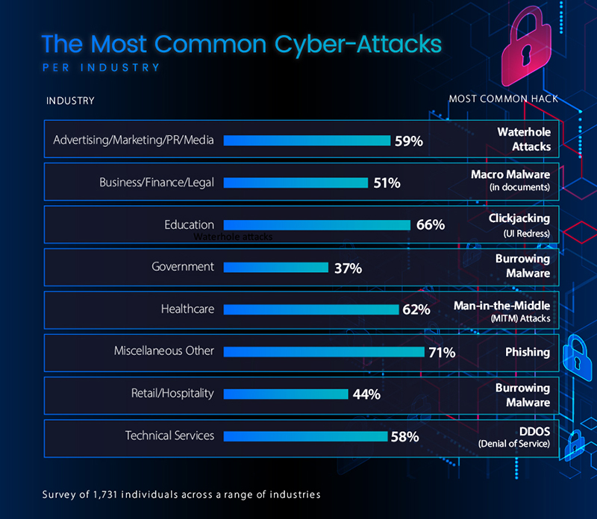

**Conclusion :**

Analyzing cybercrime trends reveals a persistent evolution in tactics, techniques, and targets. From ransomware attacks to phishing scams, cybercriminals adapt swiftly, exploiting vulnerabilities for financial gain, espionage, or disruption. However, amidst these challenges, proactive measures are emerging. Collaboration between industry, government, and cybersecurity experts is crucial for developing robust mitigation strategies. These strategies must encompass technological innovations, threat intelligence sharing, user education, and regulatory frameworks. By staying ahead of emerging threats and fostering a culture of cybersecurity, organizations can fortify their defenses and mitigate the impact of cybercrime in an increasingly digitized world.